

GPSOnline Application Run Book

Version 0.1
2013-12-04



Revision History
Version | Date | Author | Description
0.1 | 2013-12-04 | Syed Kaleemulla | Initial version

GPSOnline Dev Details

Weblogic Console: http://142.113.108.225:12201/sbconsole
User: XXXXXXXX
Password:- XXXXXXXXX

Application Specific URL for Server 1:-

Non-Secure: http://142.113.108.225:12201/GPSOnlineNS?wsdl
Secure: https://142.113.108.225:12202/GPSOnline?wsdl

Physical Server | Node Name | Type | IP | Port | Port (SSL)
ALIC5U  142.113.108.225 | ESB52G_ADMIN | Admin server | 142.113.108.225 | 12201 | 12202

Database Details:

Dev:
Database Name: DVGPS1DB
Host Name: 142.113.108.159
Port: 2073
Username: GPSDEV_ADMIN
Password: gpsdev_admin1

SIT
Database Name: DVGPS1DB
Host Name: 142.113.108.159
Port: 2073
Username: GPSSIT_ADMIN
Password: gpssit_admin1

Log Retention Period
Application and Server logs are achieved daily and backup.
Cron job need to schedule every day to run the scripts at 11:50 PM EST on all servers.

Log | Archive Period | Retention Period
Application Log | Daily | ?? Days
Server Log | Daily | ?? Days

Weblogic Server Configurations

Weblogic Admin Server Configuration
CONFIGURATION | VALUE
MEMORY
(Minimum, Maximum)
Heap Size per Manage Server

GPSOnline Application Server Recovery

In case of system outage (i.e. out of memory, server crashed) or for deployment, the server has to be restarted. The following procedure shows the procedure to bounce/recover the server.

Admin Server Restart
To restart the Admin server, shutdown through Console or Unix then start it up again via the UNIX box startup script.

Shutting Down Admin Server
Shutting down the Admin server should be done in Weblogic Console. If Weblogic Console is not available, shutdown the Admin server through Unix

Terminate Admin server Through Console

Following are the steps
- Login to the Weblogic Console:

- Goto Server → ESB52G_ADMIN

- Select Shutdown → Force Shutdown Now

- Confirm the Weblogic Console is inaccessible:

Terminate Admin server Through Unix

Only terminate Admin server through Unix if we cannot access Weblogic Console.

Following are the steps for ON Region
- Login to ALIC5U.on.bell.ca Unix Box
- Capture the Admin server pid
ps –ef | grep devgps
- Identify the Admin server (ESB52G_ADMIN) $PID
- Kill the server by running the following:
kill -9 $PID

Starting Admin Server

- Login and goto the domain directory
cd /srvrs/devgps/domains/ESB52G/

- Start the Admin server with script
./startAdminserver.sh

- Tail the nohup.out to ensure
tail –f nohup.out

- Access the Weblogic Console to confirm the Admin server is up

Pre-Deployment Process

Backup Existing Files

The next step is to do a full backup of the current application’s EAR file.

Backup Existing Application

Login on each server (ALIC5U.on.bell.ca), go to the following directory:

For Admin server:
- Login to Unix goto the backup directory
cd /srvrs/devgps/domains/ESB52G/backup/applications

- Create new backup folder
mkdir BACKUP_${current_date}_${release_name}

- Goto the current application directory
cd /srvrs/devgps/domains/ESB52G/apps

- Copy the current application EAR files to backup directory
cp*.ear /srvrs/devgps/domains/ESB52G/BACKUP_${current_date}_${release_name}

- Confirm the files are copied properly
ls -la /srvrs/devgps/domains/ESB52G/BACKUP_${current_date}_${release_name}

Deployment Procedure

Deploy Application

Deploy gpsCore as Library

- Open the weblogic administration console in a browser and login
- Click the Lock and Edit button on the left side of the console
- Click on the Deployments link in the treeview on the left
- Click on the Install button
- Navigate to the directory /srvrs/devgps/domains/ESB52G/apps using the treeview
- Select the gpsCoreEAR.ear application by clicking the radio button and click Next
- Make sure Install this deployment as Library is selected and click Next
- This screen allows you to target the application, target the application to the Admin. Click Next
- Click Finish to finish the deployment
- You should now be back at the main Deployments screen
- Click Activate Changes button in the upper left corner
- The application is now deployed as Library to the admin server.

Deploy EJB Project as Application

- Open the weblogic administration console in a browser and login
- Click the Lock and Edit button on the left side of the console
- Click on the Deployments link in the treeview on the left
- Click on the Install button
- Navigate to the directory /srvrs/devgps/domains/ESB52G/apps using the treeview
- Select the GPSCoreEJBProjectEAR.ear application by clicking the radio button and click Next
- Make sure Install this deployment as Application is selected and click Next
- This screen allows you to target the application, target the application to the Admin. Click Next
- Click Finish to finish the deployment
- You should now be back at the main Deployments screen
- Click Activate Changes button in the upper left corner
- The application is now deployed as Library to the admin server.

Deploy GPSOnline Project from OSB

- Open the OSB administration console in a browser and login
- Click the Create button on the left side of the console
- Click on the System Administration link in the left
- Click on the Import button
- Browse and select the GPSOnline SBConfig jar file
- Click on Import
- Activate the session

Sanity Check / Test

Confirm Application Status
To confirm the Application has been successfully deployed. Follow steps below:

- Login to the Weblogic Console:
- Go to Deployments
- Navigate through all Apps and ensure all applications are in Active status

Technical Sanity Test
Perform technical sanity test for using front door URL by retrieving the WSDL

GPSOnline Project Front Door URL:
http://142.113.108.225:12201/GPSOnlineNS?WSDL

Soap UI Testing:-
Import the below mentioned “GPSOnline-soapui-project.xml” project into your SOAP UI and test service.



Please refer to the below mentioned screens for more information.

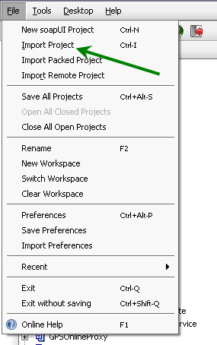

Test the service by executing the test

Please find below the attached request-response.
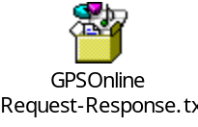
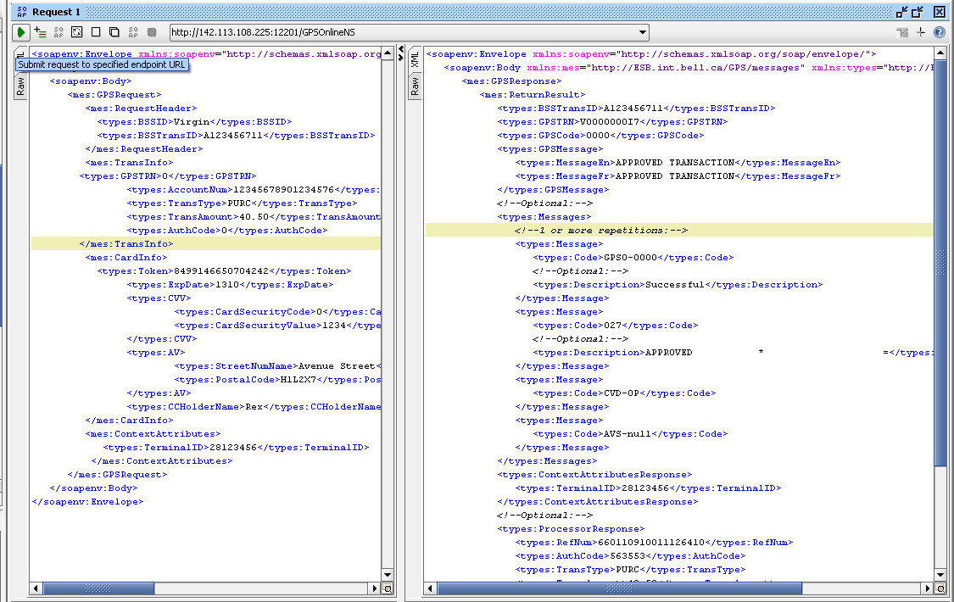

Log file details:-

GPSCore log file (ALIC5U.on.bell.ca);
/srvrs/devgps/domains/ESB52G/logs/ gpsCore.log

GPSOnline log file (ALIC5U.on.bell.ca):-
/srvrs/devgps/domains/ESB52G/servers/ESB52G_ADMIN/logs

